July 1, 2022

On behalf of the Association of Ohio Health Commissioners (AOHC), I would like to invite you to participate in our 2022 Fall Conference, to be held Wednesday, September 14 through Friday, September 16, 2022, at the Embassy Suites in Dublin (northwest Columbus), Ohio.

Public health in Ohio covers a broad range of clinical, environmental health, and health promotion services. The members of AOHC are the health commissioners of the local health departments throughout the state. As the “CEOs” of their local health departments, health commissioners make purchasing and other decisions for their departments.

AOHC’s Annual Fall Conference is a “must attend” continuing educational opportunity for Ohio’s health commissioners and their staff, as well as strategic staff members of the Ohio Department of Health and other public health associations in Ohio. Total conference attendance is approximately 275 people, including health commissioners, medical and nursing directors, and environmental health professionals. Virtually every local health district in Ohio is represented at this conference.

We hope your organization will choose to participate in this conference through our vendor trade show (exhibit dates are 9/15 and 9/16) or a variety of sponsorship opportunities. No matter how you choose to participate, your company will benefit from the exposure it receives throughout the conference.

If you are interested in participating in our Fall Conference, please review the enclosed materials (cover letter, exhibitor guidelines, and application), complete the enclosed registration form, and return it along with the appropriate fee to the AOHC Office. Register early, so we can recognize your support in our conference materials.

If you have any questions, please contact me or Denise Ross at (614) 781-9556 or aohc_3@aohc.net. Our tax ID number is 31-0668711. I look forward to working with you!

Sincerely,

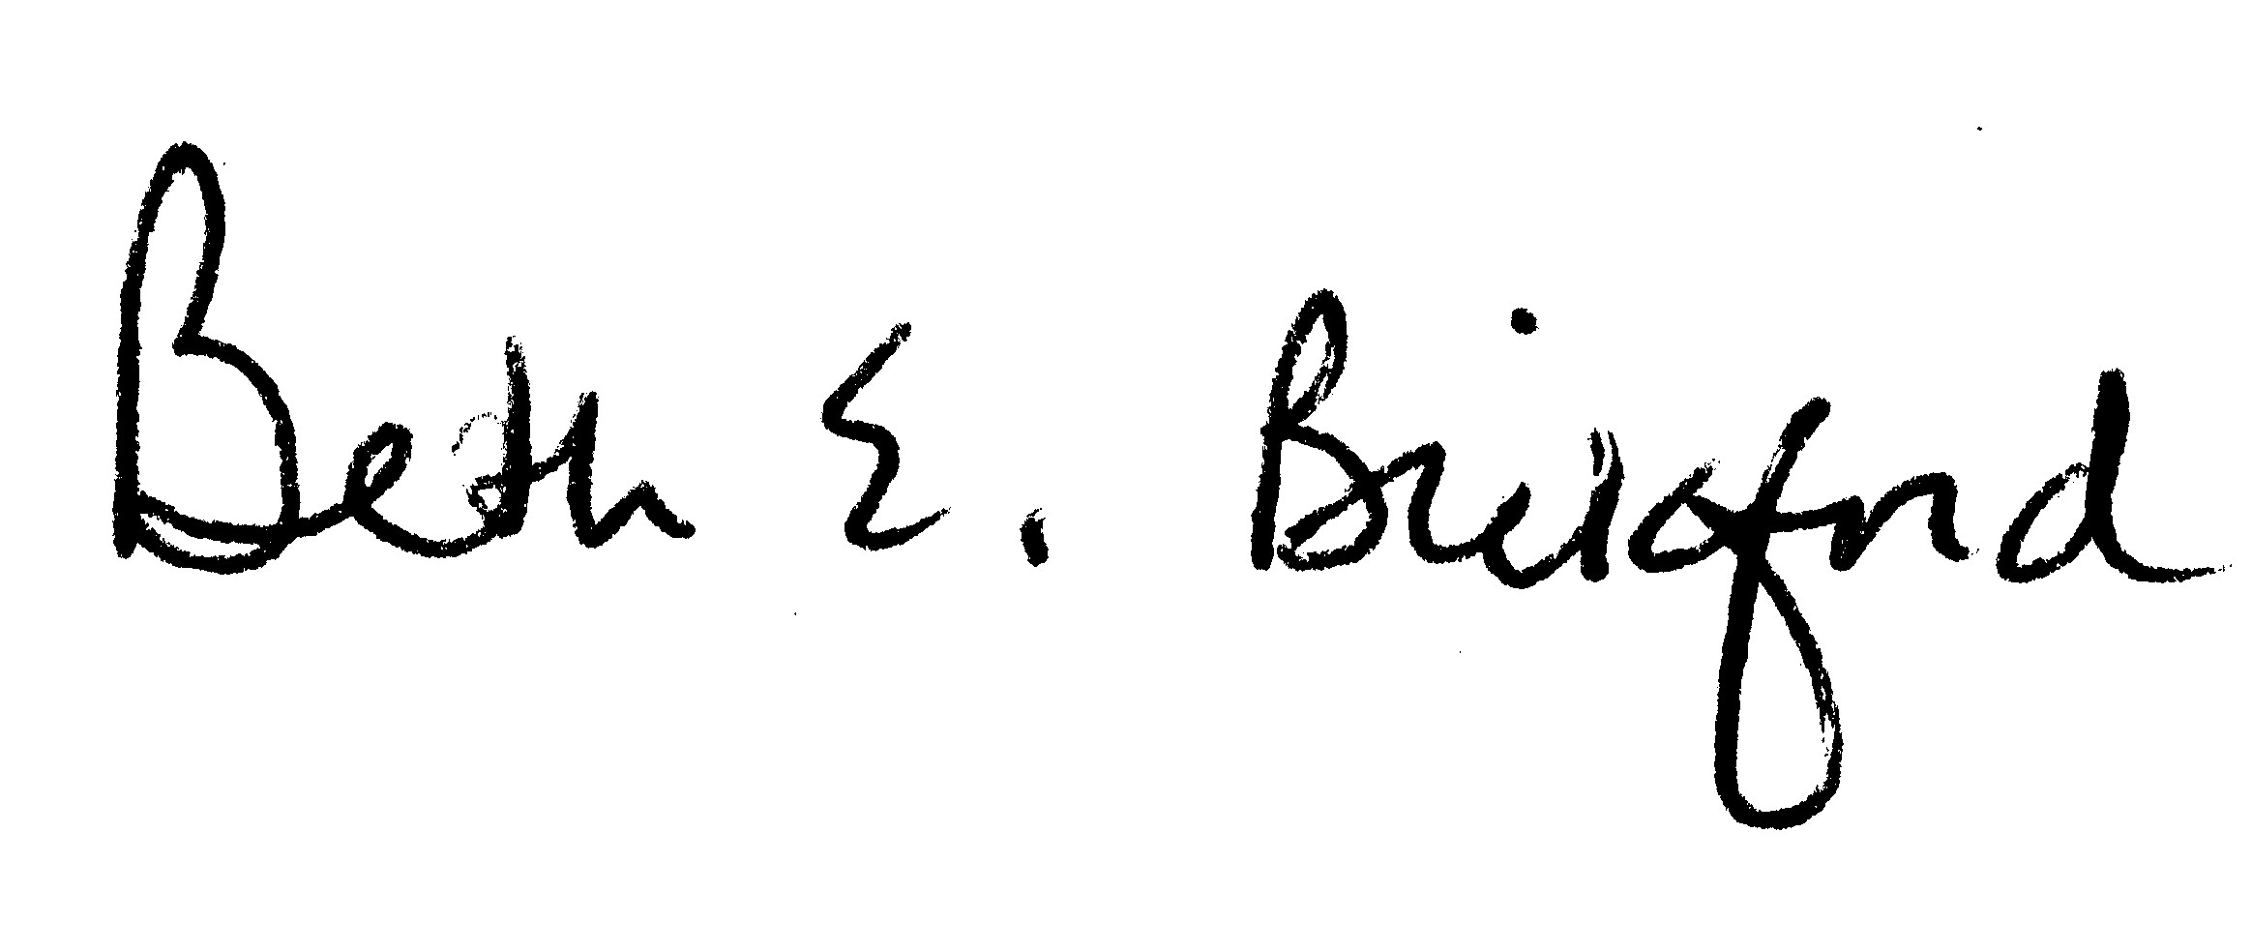
Beth E. Bickford, MS, RN
Executive Director

Enclosures

