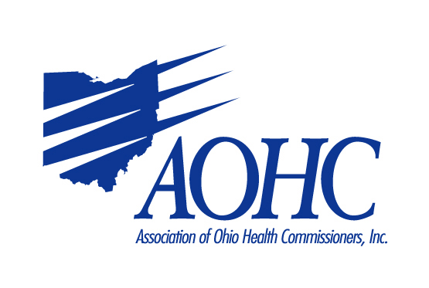
Please complete the following information and return to:
AOHC; 110A Northwoods Blvd; Columbus, Ohio 43235
Fax Number: 614-781-9558
Email: aohc_3@aohc.net
Date: __________________

Name: __________________________________________________________________________________________

Company Name: _________________________________________________________________________________

Type of Industry: ________________________________________________________________________________

Address: _______________________________________________________________________________________

City: ______________________________________ State: ___________________ Zip________________________

Phone: ______________________Fax: ____________________E-Mail____________________________________

Special Needs (electrical outlets, internet): ___________________________________________________________

Nature of the Exhibit: ____________________________________________________________________________

Names of Persons Attending: ______________________________________________________________________

_______________________________________________________________________________________________

I am bringing a voluntary gift for the last day lunch drawing: Yes _________ No ________

I am interested in providing in other educational opportunities (i.e., webinars): Yes _________ No ________

Costs:
Exhibit Space (includes meals for 2 people per day) $800 __________
Sponsor Opening Night Reception (includes exhibit space) $1500 __________
Sponsor President’s Reception (includes exhibit space) $1500 __________
Sponsor (5) District Breakfasts (includes exhibit space) $1500 __________
Sponsor Afternoon Break (includes exhibit space) $1500 __________
Exclusive sponsorship of above activity (additional cost) $1500 __________
Additional meals $35 per person/day # meals Thursday ____ # meals Friday____ = __________

Total __________
Check enclosed: ___________ Check to be mailed later: __________

* * * * * Deadline is August 5, 2022, to be included in conference brochure * * * * *

Please make checks payable to: Association of Ohio Health Commissioners. Unfortunately, we cannot accept payment via credit card.

No requests for cancellation will be accepted or refunds issued after July 29, 2022. The Association of Ohio Health Commissioners Fall Conference Committee has taken every precaution against loss or injury but shall not be responsible for any loss, damage, injury, or theft that may occur to exhibits, exhibitors, or employees during or after the meeting. There will be no refunds for exhibitors who fail to show. Acceptance is not an indication of endorsement for any product or service by the Association of Ohio Health Commissioners.

