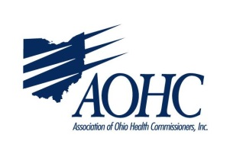
Proponent Testimony for Senate Bill 121
October 1, 2019
Senate Education Committee

Chairwoman Lehner, Vice Chair Terhar, Ranking Member Fedor, and members of the Senate Education Committee, I am Joe Mazzola, Franklin County Health Commissioner and President-Elect of the Association of Ohio Health Commissioners (AOHC). Thank you for the opportunity to provide proponent testimony for Senate Bill 121.
As a public health professional, I feel compelled to remind you of some staggering statistics:
- The obesity rate in Ohio is at an all-time high, and is continuing to climb (CDC).
- Teens spend an average of six hours and 40 minutes on a screen (Nielson).
- US life expectancy in the past few years has actually fallen, resulting in the unfortunate fact that our children and grandchildren will not live as long as we will (CDC)!
- Ohio is one of the only states in the country without comprehensive health education standards.
That’s bad news! The good news is that there are many excellent models to learn from, at both the national and state level – California, New York, and our neighbor to the north are often cited in the literature as excellent examples of what states can do in this regard. SB 121 offers an opportunity to impact this issue in Ohio in a positive way!
We know the schools have many requirements and limited resources – one could argue that the standards proposed in SB 121 will just add to the long list of things schools have to do! But can we afford not to try to address this problem that affects the health of our children and our state? In this recent budget bill, the legislature adopted many provisions that will support the health and welfare of our children. These proposed standards will do the same.
Public Health is about prevention, the foundation of keeping our community members healthy– therefore, we are asking for your support of standardized health education standards for Ohio’s school children. AOHC is committed to working with stakeholders through the legislative process to find a solution that is workable for all; local health districts are committed to working with the schools in our communities to achieve successful implementation.
I ask for your favorable consideration of SB 121. Thank you again, Madam Chair, for the opportunity to testify on Senate Bill 121. I would be happy to answer any questions that members of the Committee may have.

